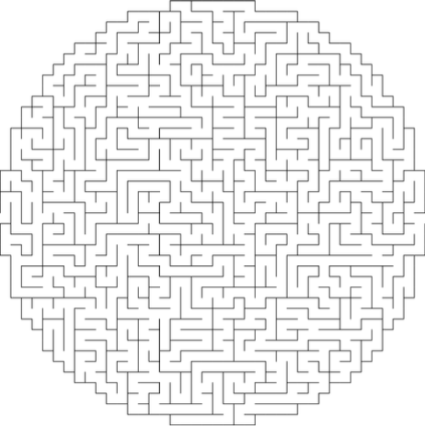
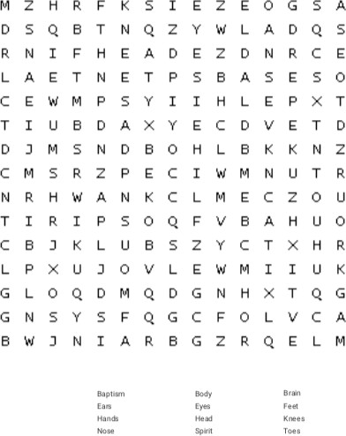
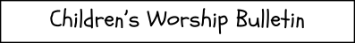
St. Paul’s UCC
301 W. Penn Avenue
Robesonia, PA19551
610-621-5770
MAZE
Many Parts, One Body
1 Corinthians 12:27
Word Search
Copyright © Sermons4Kids, Inc. May be reproduced for Ministry Use

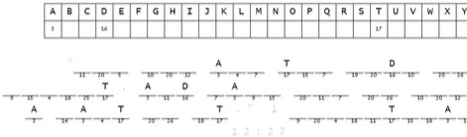
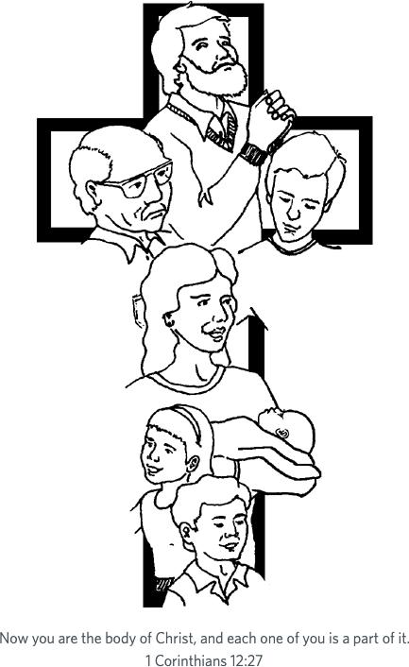
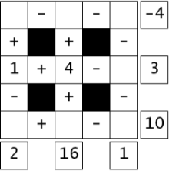
Decoder Puzzle
Each number represents a letter of the alphabet. Substitute correct letter for the numbers to reveal the coded words.
Mystery Math
Fill in the missing numbers. The missing values are the whole numbers between 1 and 9. Each number is only used once.
Each row is a math equation.
Each column is a math equation. Remember that multiplication and division are performed before addition and subtraction.

