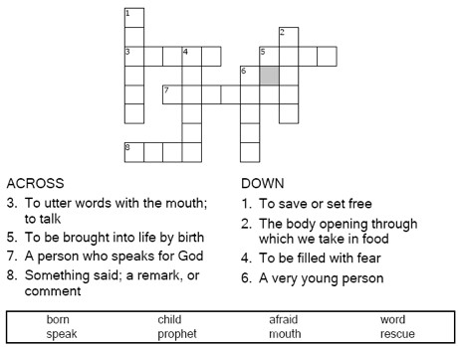
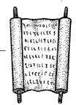
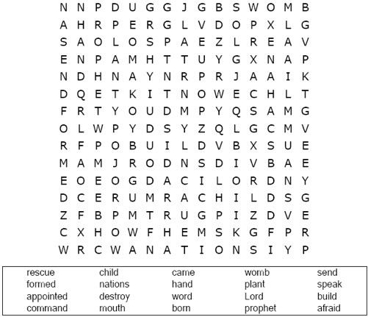


St. Paul’s UCC
301 W. Penn Avenue
Robesonia, PA 19551
610-621-5770
Jeremiah 1:4-10
Copyright © Sermons4Kids, Inc. May be reproduced for Ministry Use
Children’s Worship Bulletin


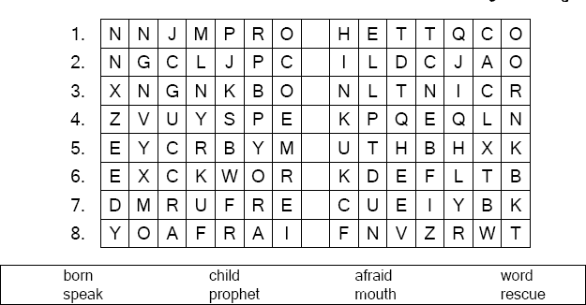
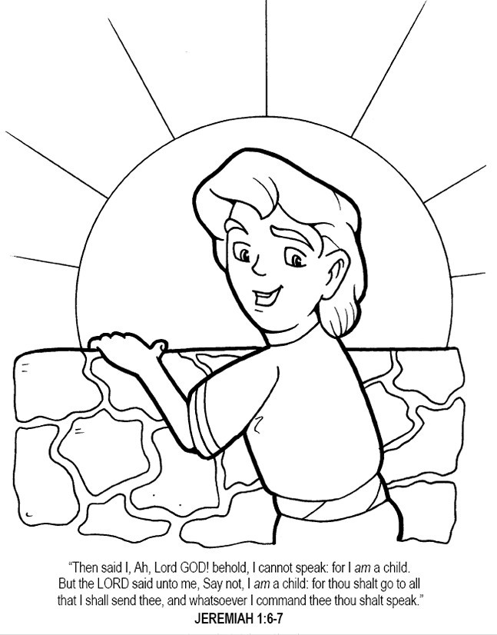
Each line of the puzzle has one word hidden in a list of random letters. The blank space is a missing letter that belongs to that word. Fill in the missing letter
Copyright © Calvary Chapel Used by permission

