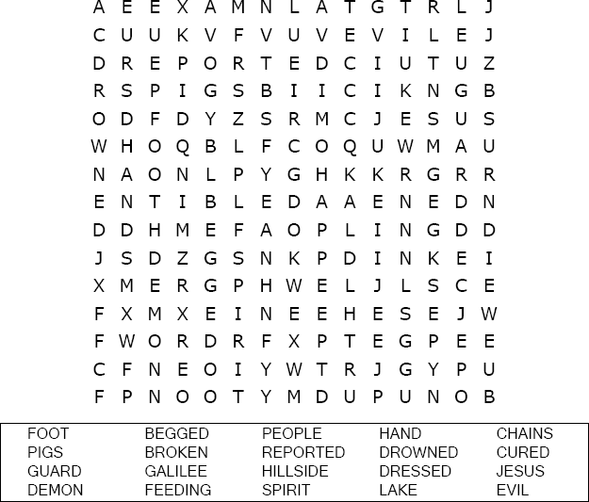
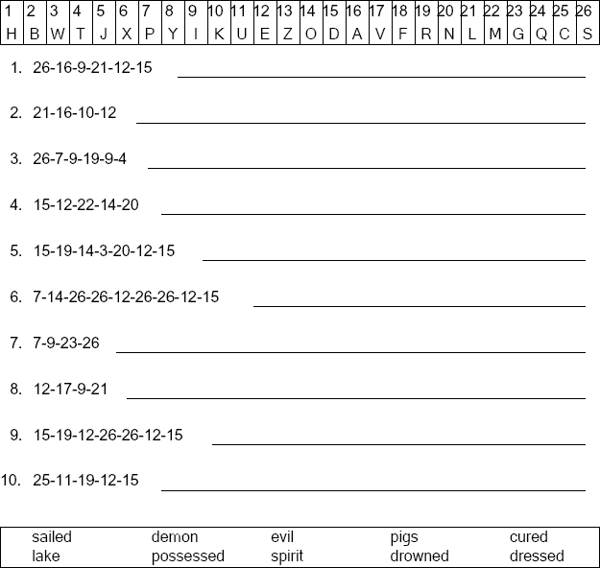

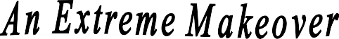

St. Paul’s UCC
301 W. Penn Avenue
Robesonia, PA 19551
610-621-5770
Luke 8:35
Copyright © Sermons4Kids, Inc. May be reproduced for Ministry Use
Children’s Worship Bulletin

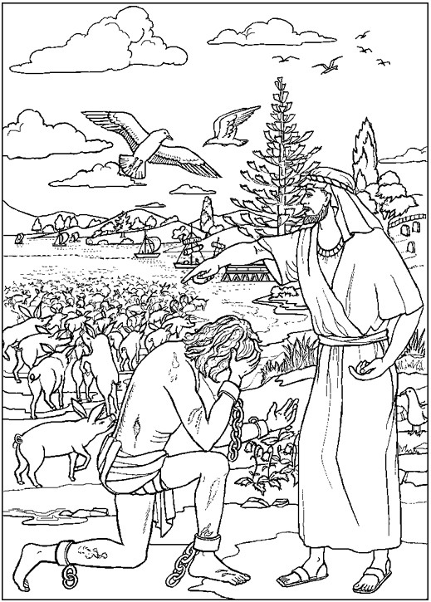

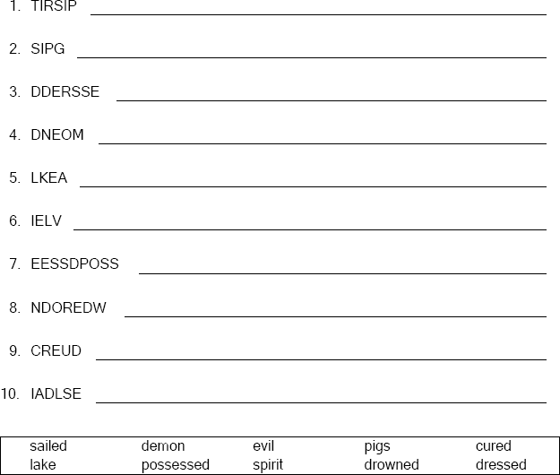

Unscramble the letters and write the word correctly .
Copyright © ABDA Acts - Arts and Publishing Used by permission.

